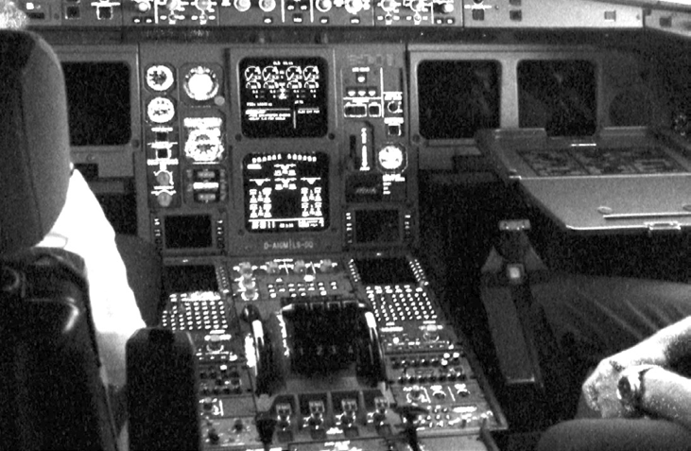

**Interrupts and Handlers**

***Objective: In this lab you will build a LKM called*** interkey***. It will exercise some of the Linux kernel interrupt handling routines. Specifically, your module will create a handler for the keyboard that will detect when the ESC key is pressed and log it.***

**Reference**: LKI/Lab8

1. The following output demonstrates what your module should print to the debug log.

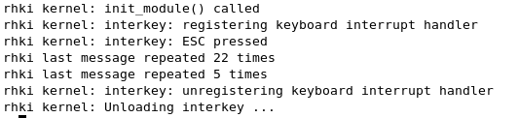

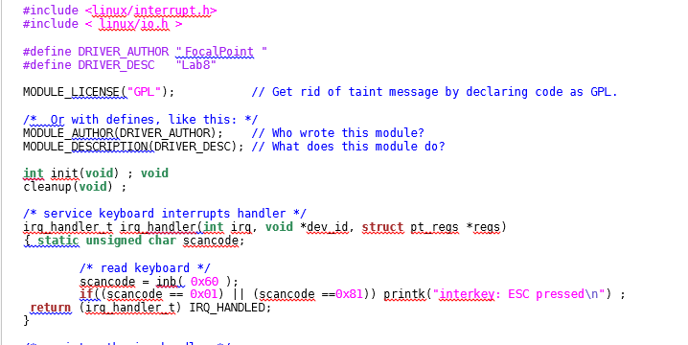

* Complete the code to register and unregister the irq handler.

